European Project EU-MERCI: website launched to collect and disseminate best practices on energy efficiency
This communication channel will provide a tool for interaction with policy and industrial stakeholders, data collection on the European industrial sector, and sharing of best practices

Rome, June 2016 – The website www.eumerci.eu – which illustrates the EU-MERCI project vision and aims, the managing consortium, the planned activities and events, and the opportunities to contribute to the project development – is online. The EU-MERCI project is funded by Horizon 2020 (Nr. 693845) and will provide a large database of good practices to promote energy efficiency and competitiveness in the industrial sector.
The selection of best practices will be mainly based on the analysis of thousands of realized projects at European level in several industrial sectors. In the early months of the project many case studies have been collected and analyzed. The best practices database will be available from February 2017, after the first year of operation.
In the meantime, the launch of the website will allow the collection of best practices coming directly from enterprises belonging to different industrial sectors from all over European countries. All enterprises that implemented interesting energy efficiency practices are thus invited to share their experiences and results using the specific form included in the webpage: Do you have best practice to share?
In this phase it will also be appreciated the compilation of a company questionnaire, through which it will be possible to understand the European industry level of knowledge and awareness about difficulties and benefits in improving energy efficiency in industrial processes. The results will be used to support industries interested in implementing models and best practices already realized in other industries.

Based on the analysis of real-world applications, EU-MERCI will assess the effectiveness of policies and schemes supporting energy efficiency in the industrial sector (as established by art. 7 of Directive 2012/27/EU) over the next two years.
EU-MERCI, that is coordinated by RSE, will also share the best practices database, collected through a substantial program of capacity building and dissemination with the European industrial sector and the policy makers.
The project partners are: Ricerca sul Sistema Energetico, Italy (RSE); JIN Climate and Sustainability, Netherlands (JIN); Center for Renewable Energy Sources and Saving, Greece (CRES); Polish National Energy Conservation Agency, Poland (KAPE); Austrian Energy Agency, Austria (AEA); Federazione italiana per l’uso razionale dell’energia, Italy (FIRE); Carbon Trust, UK (Carbon Trust); Black Sea Energy Research Centre, Bulgaria (BSERC); Energy Restructuring Agency, Slovenia (ApE); Spread European Safety SPES GEIE (SPES); Centre for the Promotion of Clean and Efficient Energy in Romania, Romania (ENERO).
EU-MERCI is supported by several government, institutional, industrial, environmental and world energy end-users organizations.

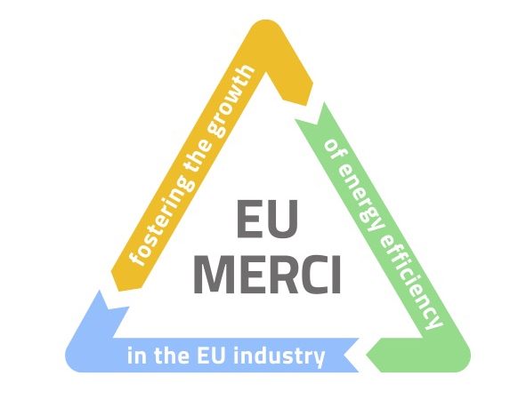
The consortium is looking for industrial and institutional players who want to participate actively in the project by making available databases and best practices on the energy efficiency applications in the industry.
If interested, please send an email to info@eumerci.eu.

